**Practical-1**

Q1-Design a class Complex having a real part (x) and an imaginary part (y). Provide methods to perform the following on complex numbers:

• Add two complex numbers. Multiply two complex numbers. toString() method to display complex numbers in the form: x+iy

Code:-

|  |
| --- |
| **public class** ComplexNumber{ |
| **private int** x; |
| **private int** y; |
| **public** ComplexNumber(**int** real, **int** imaginary) |
| { |
| this.x=real; |
| this.y=imaginary; |
| } |
| **public** ComplexNumber add(ComplexNumber o) |
| { |
| return new ComplexNumber(this.x + o.x , this.y+o.y); |
| } |
|  |
| **public** ComplexNumber multiply(ComplexNumber o) |
| { |
| return new ComplexNumber(this.x*o.x - this.y*o.y , this.x*o.y + o.x*this.y); |
| } |
| **public** String toString() |
| { |
| return x +"+ i "+y; |
| } |
| **public static void** main(String[] args) |
| { |
| ComplexNumber c1= new ComplexNumber(1,2); |
| ComplexNumber c2= new ComplexNumber(3,4); |
| System.out.println("Complex Number 1:"+c1); |
| System.out.println("Complex Number 2:"+c2); |
| System.out.println("Sum:"+c1.add(c2)); |
| System.out.println("Product:"+c2.multiply(c1)); |
| } |
| } |

Output:-

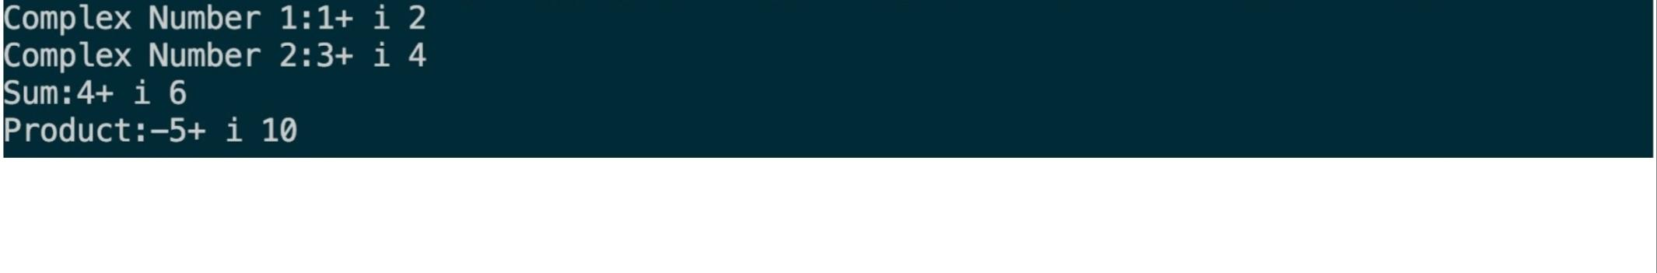

PRACTICAL 2

# Objective

Create a class TwoDim which contains private members as x and y coordinates in package P1. Define the default constructor, a parameterized constructor and override toString() method to display the co-ordinates. Now reuse this class and in package P2 create another class ThreeDim, adding a new dimension as z as its private member. Define the constructors for the subclass and override toString() method in the subclass also. Write appropriate methods to show dynamic method dispatch. The main() function should be in a package P.

# Code

First package(p1)

package Dhruv_Java**.**p1;

**public class** twodim {

**private int** x;

**private int** y;

**public** twodim(){ this.x=0; this.y=0;

}

**public** twodim(**int** x,**int** y){ this.x=x;

this.y=y;

}

**public** String toString(){

return ("Coordinates: x="+x+" y="+y);

}

}

# Second Package(p2)

package Dhruv_Java**.**p2; import Dhruv_Java**.**p1**.\***;

**public class** threedim **extends** twodim {

**private int** z;

**public** threedim() { super(0, 0);

this.z = 0;

}

**public** threedim(**int** x,**int** y,**int** z) { super(x, y);

this.z = z;

}

**public** String toString() {

return super.toString() + " z=" + z;

}

}

Main package(P)

package Dhruv_Java**.**p; import java**.**util**.\***; import Dhruv_Java**.**p1**.\***; import Dhruv_Java**.**p2**.\***;

import Dhruv_Java**.**p1**.**twodim;

**public class** assignment{

**public static void** main(String[] args) { twodim obj;

obj=new twodim(2,3); System.out.println(obj); obj=new threedim(2,3,6); System.out.println(obj);

}

}

# OUTPUT:-

# Practical 3

**Q.Define an abstract class Shape in package P1. Inherit two more classes: Rectangle in package P2 and Circle in package P3. Write a program to ask the user for the type of shape and then using the concept of dynamic method dispatch, display the area of the appropriate subclass. Also write appropriate methods to read the data. The main() function should not be in any package.**

**Code:-**

**P1/Shape.java**

package P1;

public abstract class Shape {

protected abstract void getData() throws java.io.IOException; public abstract double area() throws java.io.IOException;

}

## P2/Rectangle.java

package P2; import java.io.*; import P1.*;

public class Rectangle extends Shape { private double length;

private double breadth;

protected void getData() throws IOException {

BufferedReader br = new BufferedReader(new InputStreamReader( System.in

));

System.out.print("Enter Length of Rectangle: "); length = Double.parseDouble(br.readLine()); System.out.print("Enter Breadth of Rectangle: "); breadth = Double.parseDouble(br.readLine());

}

public double area() throws IOException { getData();

return length * breadth;

}

}

## P3/Circle.java

package P3; import java.io.*; import P1.*;

public class Circle extends Shape { private double radius;

protected void getData() throws IOException {

BufferedReader br = new BufferedReader(new InputStreamReader(

System.in

));

System.out.print("Enter Radius of Circle: "); radius = Double.parseDouble(br.readLine());

}

public double area() throws IOException { getData();

return Math.PI * radius * radius;

}

}

## practhree.java

package Dhruv_Java**.**Dhruv_Java; import java**.**io**.\***;

import Dhruv_Java**.**P1**.\***; import Dhruv_Java**.**P2**.\***; import Dhruv_Java**.**P3**.\***; **public class** practhree {

**static int** getShapeType() **throws** IOException {

BufferedReader br = new BufferedReader(new InputStreamReader(System.in)); System.out.println("==============\n SHAPE TYPE \n==============");

System.out.println(" (1) Rectangle\n (2) Circle"); System.out.print("Enter Choice: ");

return Integer.parseInt(br.readLine());

}

**public static void** main(String[] args) **throws** IOException { Shape ref;

**boolean** flag = false; while (!flag) {

switch (getShapeType()) { case 1:

flag = true;

ref = new Rectangle();

System.out.println("Area: " + ref.area() + " sq units"); break;

case 2:

flag = true;

ref = new Circle();

System.out.println("Area: " + ref.area() + " sq units"); break;

default:

System.err.println("Invalid Option"); break;

}

}

}

}

**Output:-**

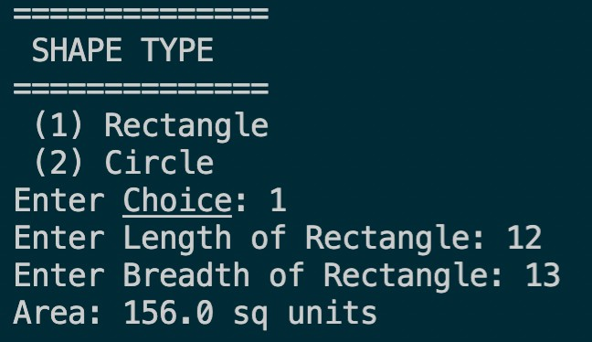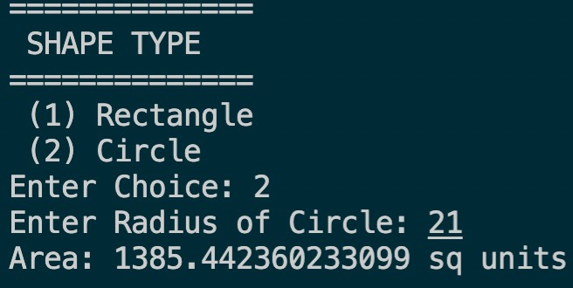

# Practical 4

**Q.Create an Exception subclass UnderAge, which prints “Under Age” along with the age value when an object of UnderAge class is printed in the catch statement. Write a class exceptionDemo in which the method test() throws UnderAge exception if the variable age passed to it as argument is less than 18.**

**Write main() method also to show working of the program.**

**Code:-**

**Underage.java:**

**package Dhruv_Java;**

**public class underage extends Exception { final private int age;**

**public underage(int age) { this.age = age;**

**}**

**@Override**

**public String getMessage() {**

**return "UnderAge: " + age + " is less than 18";**

**} }**

## exceptionDemo.java:

**package Dhruv_Java;**

**import java.util.Scanner; class exceptionDemo {**

**static void test(int age) throws underage {**

**if (age < 18)**

**throw new underage(age);**

**}**

**public static void main(String[] args) { Scanner sc = new Scanner(System.in); System.out.print("Enter Age: ");**

**int age = sc.nextInt(); try {**

**test(age);**

**System.out.println("Test Successful");**

**} catch (underage e) { System.err.println(e.getMessage()); System.out.println("Test Unsuccessful");**

**}**

**finally { sc.close();**

**}**

**} }**

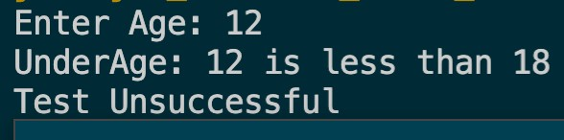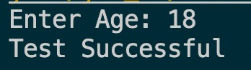**Output:-**

# Practical 5

**Q.Write a program to implement stack. Use exception handling to manage underflow and overflow conditions.**

**Code:-**

**Stack.java:**

package Dhruv_Java;

public class Stack { private int tos; private int[] array;

final private int size; public Stack(int size) { this.tos = -1;

this.size = size;

this.array = new int[this.size];

}

public void push(int e) throws StackException { if (tos == size - 1)

throw new StackException("Stack Overflow: could not push " + e); else

this.array[++this.tos] = e;

}

public int pop() throws StackException { if (this.tos < 0) {

throw new StackException("Stack Underflow: could not pop");

} else

return this.array[this.tos--];

}

public int getTOS() { return this.tos;

}

@Override

public String toString() {

return "Stack<size=" + this.size + ">";

} }

## StackException.java:

package Dhruv_Java;

public class StackException extends Exception { final private String message;

public StackException(String message) { this.message = message;

}

@Override

public String getMessage() { return this.message;

}

}

## pracfive.java:

package Dhruv_Java;

import java**.**util**.**Random;

**public class** pracfive {

**public static void** main(String[] args) {

**int** r;

Stack stack = new Stack(5);

Random random = new Random(1337);

System.out.println("Created stack of size 5..."); System.out.println("Pushing integers onto stack..."); while (true) {

r = random.nextInt(100); System.out.println("Pushing " + r + "..."); try {

stack.push(r); System.out.println(

"Elements in Stack = " + (stack.getTOS() + 1)

);

} catch (StackException e) { System.err.println(e.getMessage()); break;

}

}

System.out.println("Popping integers from stack..."); while (true) {

System.out.println(

"Elements in Stack = " + (stack.getTOS() + 1)

);

try {

System.out.println("Popped " + stack.pop() + "...");

} catch (StackException e) { System.err.println(e.getMessage()); break;

}

}

} }

## Output:-

PRACTICAL-06

Objective - Write a program that copies content of one file to another. Pass the names of the files through command-line arguments.

Code –

package Dhruv_Java; import java**.**io**.\***; import java**.**util**.\***; **class** filecopy {

**public static void** main(String arg[]) **throws** Exception { Scanner sc = new Scanner(System.in); System.out.print("Provide source file name :");

String sfile = sc.next();

System.out.print("Provide destination file name :"); String dfile = sc.next();

FileReader fin = new FileReader(sfile); FileWriter fout = new FileWriter(dfile, true); **int** c;

while ((c = fin.read()) != -1) { fout.write(c);

}

System.out.println("Copy from "+sfile+" to"+dfile); fin.close();

fout.close();

sc.close();

}

}

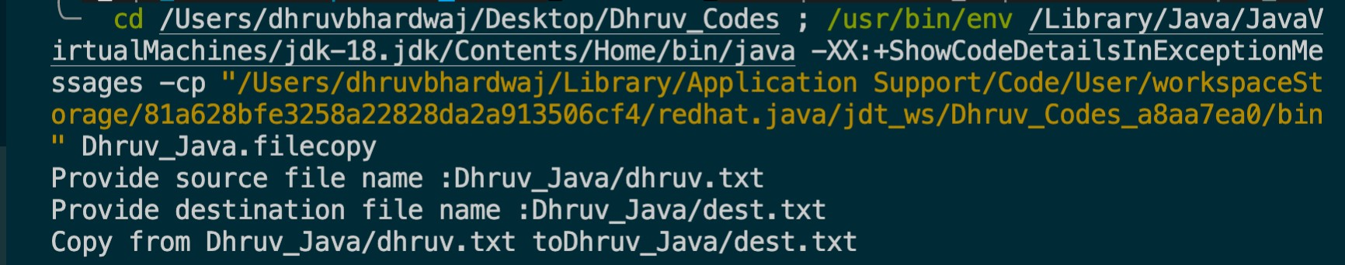OUTPUT:-

Prac 7

import java.io.BufferedReader;

import java.io.FileNotFoundException;

import java.io.LineNumberReader;

import java.io.IOException;

import java.io.InputStreamReader;

import java.io.FileInputStream;

public class Exercise17 {

public static void main(String a[]){

BufferedReader br = null;

String strLine = "";

try {

LineNumberReader reader = new LineNumberReader(new InputStreamReader(new FileInputStream("/home/students/test.txt"), "UTF-8"));

while (((strLine = reader.readLine()) != null) && reader.getLineNumber() <= 3){

System.out.println(strLine);

}

reader.close();

} catch (FileNotFoundException e) {

System.err.println("File not found");

} catch (IOException e) {

System.err.println("Unable to read the file.");

}

}

}

# PRACTICAL 8:

Objective**:** Write a program to create a frame using AWT. Implement mouseClicked(), mouseEntered() and mouseExited() events such that:

* Size of the frame should be tripled when mouse enters it
* Frame should reduce to its original size when mouse is clicked in it
* Close the frame when mouse exits it Code

Code:

import java.awt.*; import java.awt.event.*;

public class PracEight extends Frame implements MouseListener { final int length = 100;

final int breadth = 100; PracEight() { super("AWT Frame");

this.setSize(this.length, this.breadth); this.setLayout(null); this.setVisible(true); this.addMouseListener(this); this.addWindowListener(new WindowAdapter() {

public void windowClosing(WindowEvent e) { dispose();

}

});

}

public static void main(String[] args) { new PracEight();

}

@Override

public void mouseClicked(MouseEvent e) { this.setSize(this.length, this.breadth);

}

@Override

public void mousePressed(MouseEvent e) {

}

@Override

public void mouseReleased(MouseEvent e) {

}

@Override

public void mouseEntered(MouseEvent e) { this.setSize(3 * this.length, 3 * this.breadth);

}

@Override

public void mouseExited(MouseEvent e) { this.dispose();

}

}

**OUTPUT:**

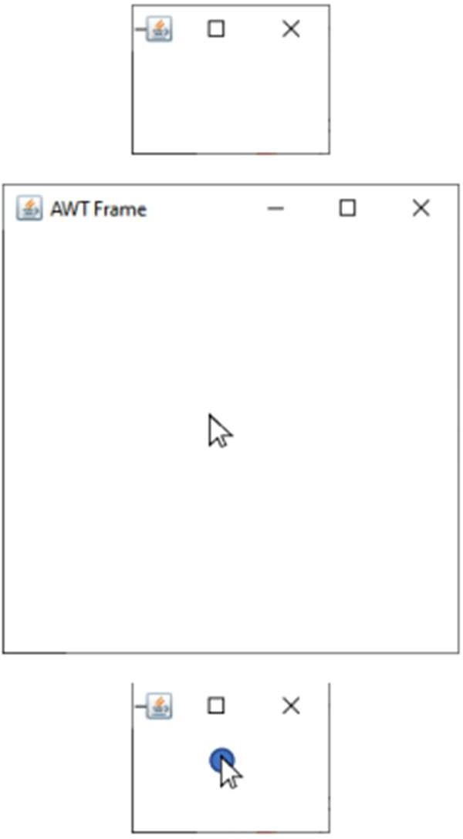

# PRACTICAL 9:

Objective: Using AWT, write a program to display a string in frame window with pink color as background.

Code:

import java.util.*; import java.awt.*; import java.awt.event.*;

public class PracNine extends Frame{ Label l;

PracNine(){

super("AWT Pink");

i = new Label("This is a Label");

i.setBounds(25,60,250,30); i.setAlignment(Label.CENTER); this.add(i); this.setSize(300,100); this.setLayout(new FlowLayout()); this.setBackground(Color.pink); this.setVisible(true);

this.addWindowListener(new WindowAdapter(){ public void windowClosing(WindowEvent e) { dispose();

}

});

}

public static void main(String[] args){ new PracNine();

}

}

**OUTPUT:**

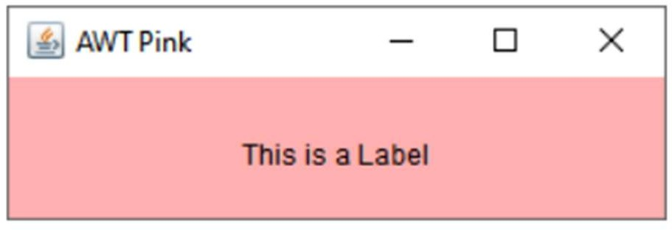

# PRACTICAL 11:

Objective: Using AWT, write a program using appropriate adapter class to display the message (“Typed character is: X”) in the frame window when user types any key.

Code:

import java.awt.*; import java.awt.event.*;

class KbdAdapter extends KeyAdapter { Label l;

KbdAdapter(Label l) { this.l = l;

}

@Override

public void keyTyped(KeyEvent e) {

l.setText("Typed character is: " + e.getKeyChar());

}

}

public class Main extends Frame { Label l;

Main() {

super("AWT Keyboard"); l = new Label("");

l.setBounds(25, 50, 250, 30); l.setAlignment(Label.CENTER); this.addKeyListener(new KbdAdapter(l)); this.add(l);

this.setSize(300, 110); this.setLayout(null); this.setVisible(true); this.addWindowListener(new WindowAdapter() {

public void windowClosing(WindowEvent e) { dispose();

}

});

}

public static void main(String[] args) { new Main();

}

}

**OUTPUT:**

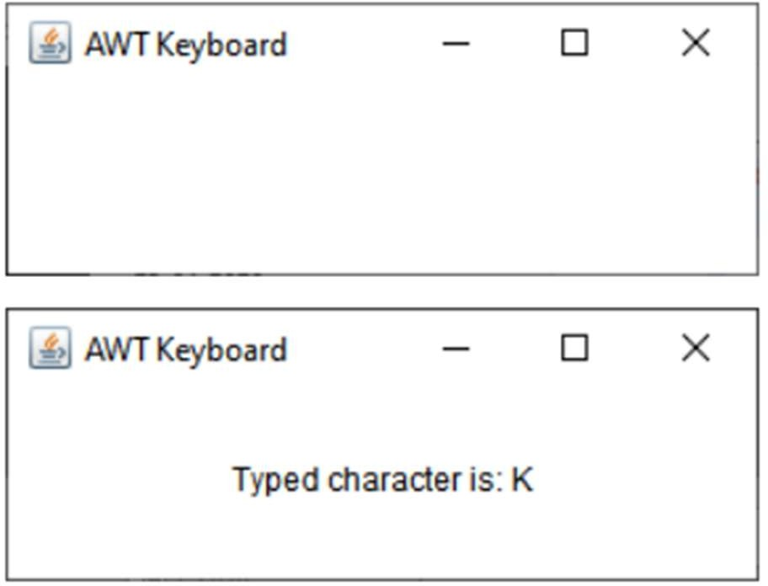

PRACTICAL 10:

Objective: Using AWT, write a program to create two buttons named “Red” and “Blue”. When a button is pressed the background color should be set to the color named by the button’s label.

Code:

import java.awt.*; import java.awt.event.*;

public class Main extends Frame implements ActionListener { Button btnRed, btnBlue;

Main() {

super("AWT Buttons"); btnRed = new Button("Red");

btnRed.setBounds(25, 50, 250, 30); btnRed.addActionListener(this); this.add(btnRed);

btnBlue = new Button("Blue"); btnBlue.setBounds(25, 100, 250, 30); btnBlue.addActionListener(this); this.add(btnBlue); this.setSize(300, 160); this.setLayout(null); this.setVisible(true);

this.addWindowListener(new WindowAdapter() { public void windowClosing(WindowEvent e) {

dispose();

}

});

}

public static void main(String[] args) { new Main();

}

@Override

public void actionPerformed(ActionEvent e) { if (e.getSource() == btnRed) {

this.setBackground(Color.RED);

}

else if (e.getSource() == btnBlue) { this.setBackground(Color.BLUE);

}

}

}

OUTPUT:

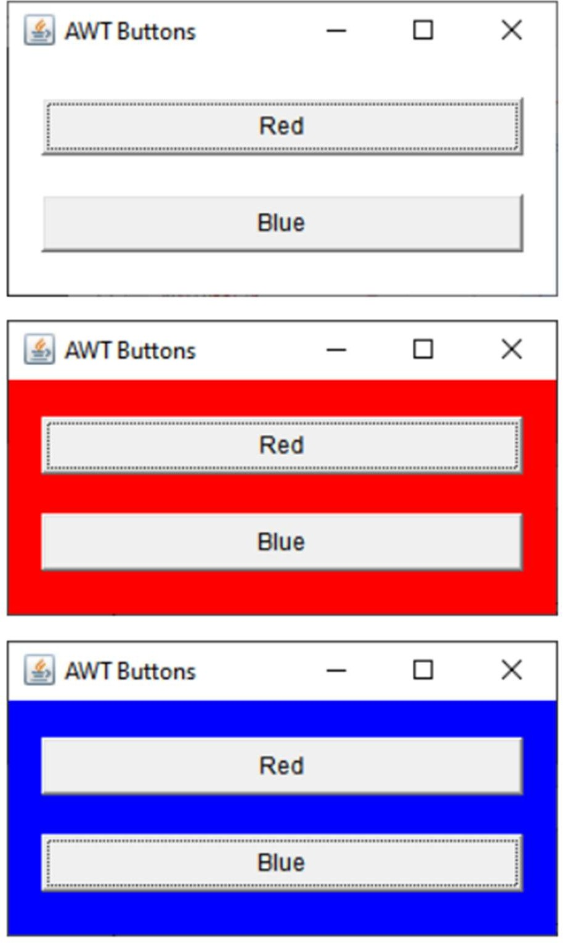

# Practical 12

**Q.Using AWT, write a program to create two buttons labelled ‘A’ and ‘B’. When button ‘A’ is pressed, it displays your personal information (Name, Course, Roll No, College) and when button ‘B’ is pressed, it displays your CGPA in previous semester.**

**Code:-**

### package Dhruv_Java; import java.util.*; import java.awt.*; import java.awt.event.*;

**public class practwelve {**

### public static void main (String[] args) {

***// create instance of frame with the label***

### Frame f = new Frame("Details");

***// create instance of frame with the label***

### final TextArea tf=new TextArea(); final TextArea tf1=new TextArea(); tf.setBounds(50,50, 160,200);

**tf1.setBounds(230,50, 160,200);**

***// create instance of button with label* Button name = new Button("Name"); Button cgpa = new Button("Cgpa");**

### String ne="Dhruv Bhardwaj"+"\n"+"B.sc.Hons.(Comp. Sci)"+"\n"+"18072"+"\n"+"ARSD COLLEGE"+"\n";

**String cg="CGPA: 9.99"+"\n";**

***// set the position for the button in frame* name.setBounds(80,250,80,30); cgpa.setBounds(260,250,80,30); name.addActionListener(new ActionListener() {**

### public void actionPerformed (ActionEvent e) { tf.append(ne);

***// tf.setText("Dhruv Bhardwaj");***

### }

**});**

### cgpa.addActionListener(new ActionListener() { public void actionPerformed (ActionEvent e) {

**tf1.append(cg);**

### }

**});**

***// add button to the frame***

### f.add(name);

**f.add(cgpa);**

### f.add(tf);

**f.add(tf1);**

***// set size, layout and visibility of frame***

### f.setSize(400,400); f.setLayout(null); f.setVisible(true);

**}**

**}**

**Output:-**

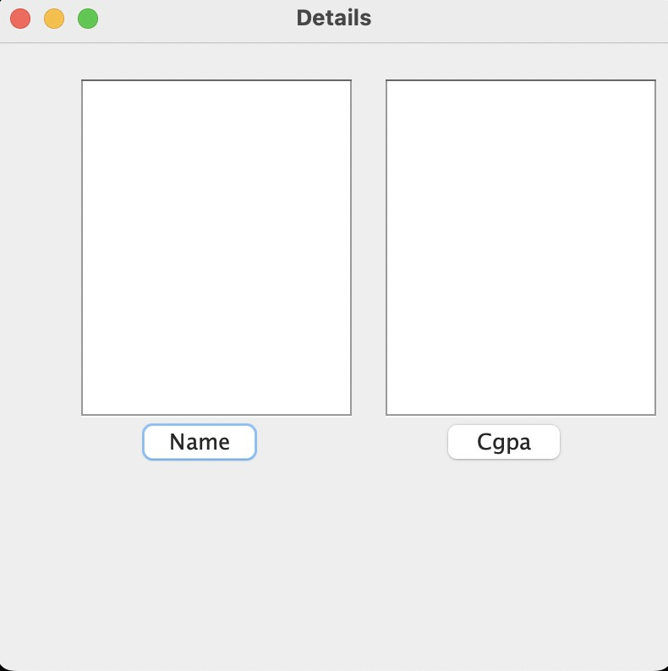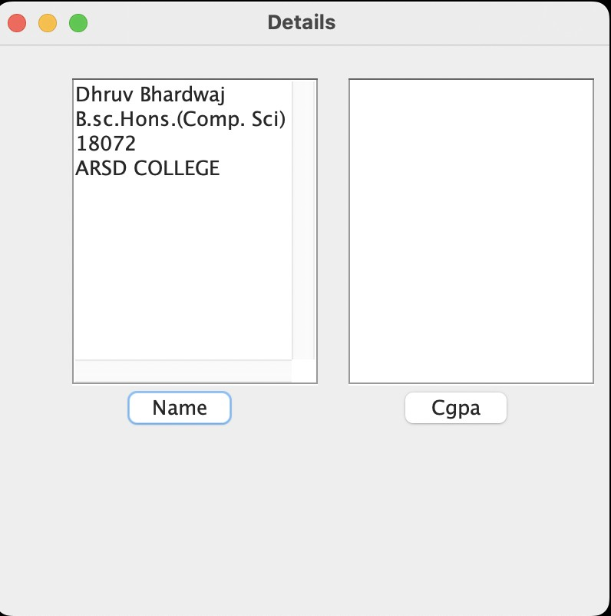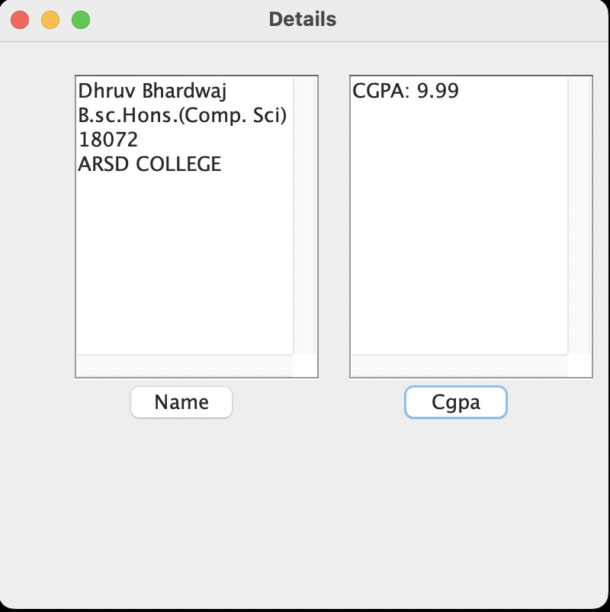

# Practical 13 Version:0.9

Q.Rewrite all the below GUI programs using Swing.

**a)Write a program to create a frame using SWING. Implement mouseClicked( ), mouseEntered( ) and mouseExited( ) events. Frame should become visible when mouse enters it.**

**Code:-**

package Dhruv_Java; import java**.**util**.\***; import java**.**awt**.\***; import java**.**awt**.**event**.\***; import javax**.**swing**.\***;

**public class** practhirtheen { JLabel l;

practhirtheen() {

JFrame f = new JFrame("Swing Frame");

l = new JLabel("", SwingConstants.CENTER); l.setBounds(15, 110, 260, 30);

f.add(l);

f.addMouseListener(new MouseAdapter() { @**Override**

**public void** mouseClicked(MouseEvent e) { l.setText("Mouse Clicked");

}

### @Override

**public void** mouseEntered(MouseEvent e) { l.setText("Mouse Entered");

}

### @Override

**public void** mouseExited(MouseEvent e) { l.setText("Mouse Exited");

}

});

f.setSize(300, 300); f.setLayout(null); f.setVisible(true);

f.setDefaultCloseOperation(JFrame.EXIT_ON_CLOSE);

}

**public static void** main(String[] args) { SwingUtilities.invokeLater(new Runnable() {

**public void** run() { new practhirtheen();

}

});

}

}

**Output:-**

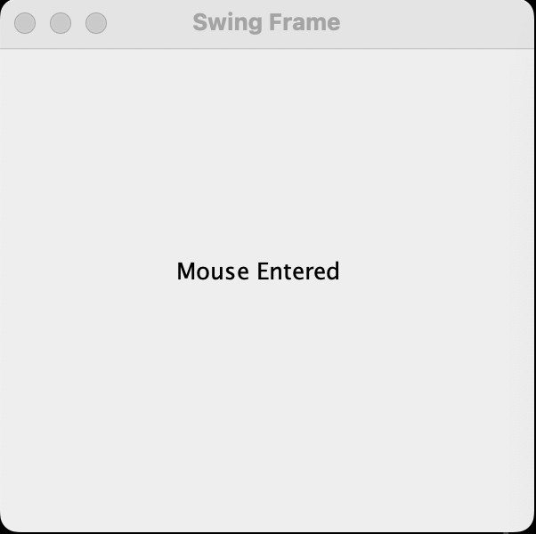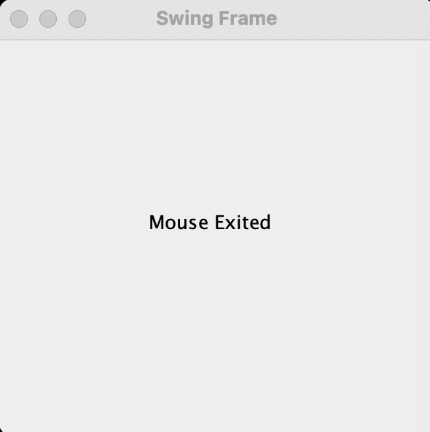

1. **Using SWING, write a program to display a string in frame window with pink color as background.**

**Code:-**

package Dhruv_Java; import java.awt.*; import java.awt.event.*; import javax.swing.*;

public class practhirtheen { JLabel l;

practhirtheen() {

JFrame f = new JFrame("Swing Pink");

l = new JLabel("This is some text", SwingConstants.CENTER); l.setBounds(15, 15, 260, 30);

f.add(l);

f.getContentPane().setBackground(Color.PINK); f.setSize(300, 100);

f.setLayout(null); f.setVisible(true);

f.setDefaultCloseOperation(JFrame.EXIT_ON_CLOSE);

}

public static void main(String[] args) { SwingUtilities.invokeLater(new Runnable() {

public void run() {

new practhirtheen();

}

});

}

}

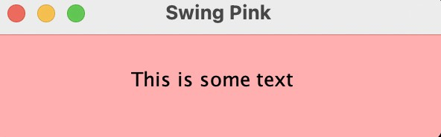**Output:-**

1. **Using SWING, write a program to create two buttons named “Red” and “Blue”. When a button is pressed the background color should be set to the color named by the button’s label.**

**Code:-**

package Dhruv_Java; iimport java.awt.*; import java.awt.event.*; import javax.swing.*;

public class practhirtheen { JButton btnRed, btnBlue; practhirtheen() {

JFrame f = new JFrame("Swing Buttons"); btnRed = new JButton("Red"); btnRed.setBounds(16, 20, 250, 30); btnRed.addActionListener(new ActionListener() {

@Override

public void actionPerformed(ActionEvent e) {

f.getContentPane().setBackground(Color.RED);

}

});

f.add(btnRed);

btnBlue = new JButton("Blue"); btnBlue.setBounds(16, 65, 250, 30); btnBlue.addActionListener(new ActionListener() {

@Override

public void actionPerformed(ActionEvent e) { f.getContentPane().setBackground(Color.BLUE);

}

});

f.add(btnBlue); f.setSize(300, 160); f.setLayout(null); f.setVisible(true);

f.setDefaultCloseOperation(JFrame.EXIT_ON_CLOSE);

}

public static void main(String[] args) { SwingUtilities.invokeLater(new Runnable() {

public void run() {

new practhirtheen();

}

});

}

}

**Output:-**

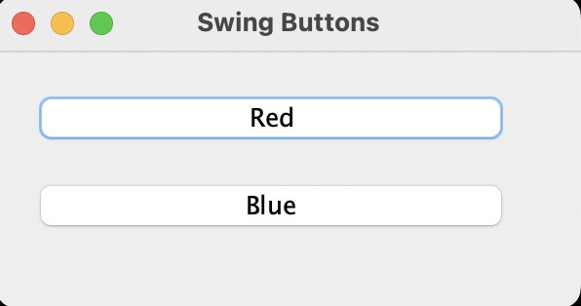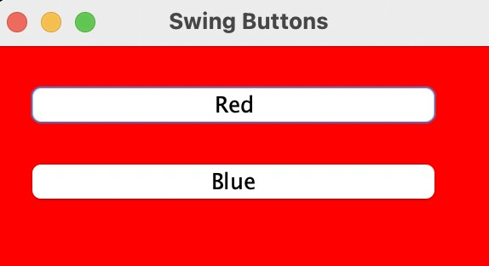

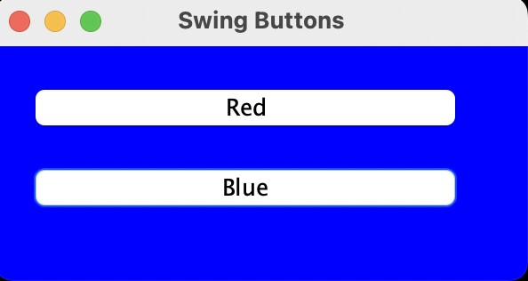

1. **Using SWING, write a program which responds to KEY_TYPED event and updates the status window with message (“Typed character is: X”). Use adapter class for other two events.**

**Code:-**

package Dhruv_Java; import java**.**awt**.\***; import java**.**awt**.**event**.\***; import javax**.**swing**.\***;

**class** KbdAdapter **extends** KeyAdapter { JLabel l;

KbdAdapter(JLabel l) { this.l = l;

}

### @Override

**public void** keyTyped(KeyEvent e) { l.setText("Typed character is: " + e.getKeyChar());

}

### @Override

**public void** keyPressed(KeyEvent e) { System.out.println("Pressed character is: " + e.getKeyChar());

}

### @Override

**public void** keyReleased(KeyEvent e) { System.out.println("Released character is: " + e.getKeyChar());

}

}

**public class** practhirtheen { JLabel l;

practhirtheen() {

JFrame f = new JFrame("AWT Keyboard");

l = new JLabel("", SwingConstants.CENTER); l.setBounds(15, 20, 250, 30); f.addKeyListener(new KbdAdapter(l)); f.add(l);

f.setSize(300, 110); f.setLayout(null); f.setVisible(true);

f.setDefaultCloseOperation(JFrame.EXIT_ON_CLOSE);

}

**public static void** main(String[] args) { SwingUtilities.invokeLater(new Runnable() {

**public void** run() { new practhirtheen();

}

});

}

}

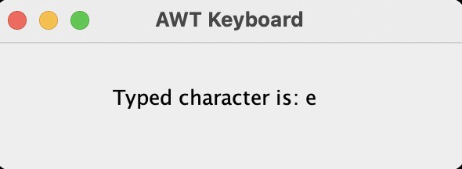Output:-

1. **Using SWING,write a program to create two buttons labelled ‘A’ and ‘B’. When button ‘A’ is pressed, it displays your personal information (Name, Course, Roll No, College) and when button ‘B’ is pressed, it displays your CGPA in previous semester.**

**Code:-**

**CGPA.java**

package Dhruv_Java; import java**.**awt**.\***; import java**.**awt**.**event**.\***; import javax**.**swing**.\***; **class** CGPA {

JLabel l;

JButton btnClose; CGPA(String cgpa) {

JFrame f = new JFrame("Previous Year CGPA");

l = new JLabel("Your CGPA was: " + cgpa, SwingConstants.CENTER); l.setBounds(20, 20, 250, 30);

btnClose = new JButton("Close"); btnClose.setBounds(90, 60, 100, 30); btnClose.addActionListener(new ActionListener() {

### @Override

**public void** actionPerformed(ActionEvent e) { f.dispose();

}

});

f.add(l); f.add(btnClose); f.setSize(310, 150); f.setLayout(null); f.setVisible(true);

f.setLocationRelativeTo(null); f.setDefaultCloseOperation(JFrame.DISPOSE_ON_CLOSE);

}

}

**INFORMATION.java**

package Dhruv_Java; import java**.**awt**.\***; import java**.**awt**.**event**.\***; import javax**.**swing**.\***; **class** Information {

JButton btnClose; JPanel panelForm;

JLabel labelName, labelCourse, labelRollNo, labelCollege; JTextField fieldName, fieldCourse, fieldRollNo, fieldCollege;

Information(String name, String course, String rollNo, String college) { JFrame f = new JFrame("Personal Information");

labelName = new JLabel("Name:"); labelName.setBounds(30, 30, 90, 23); labelCourse = new JLabel("Course:"); labelCourse.setBounds(30, 60, 100, 23); labelRollNo = new JLabel("Roll No.:"); labelRollNo.setBounds(30, 90, 80, 23); labelCollege = new JLabel("College:"); labelCollege.setBounds(30, 120, 90, 23); fieldName = new JTextField(name); fieldName.setBounds(120, 30, 210, 23); fieldName.setEditable(false);

fieldCourse = new JTextField(course); fieldCourse.setBounds(120, 60, 210, 23); fieldCourse.setEditable(false); fieldRollNo = new JTextField(rollNo); fieldRollNo.setBounds(120, 90, 210, 23); fieldRollNo.setEditable(false); fieldCollege = new JTextField(college);

fieldCollege.setBounds(120, 120, 210, 23); fieldCollege.setEditable(false);

btnClose = new JButton("Close"); btnClose.setBounds(110, 160, 140, 30); btnClose.addActionListener(new ActionListener() {

### @Override

**public void** actionPerformed(ActionEvent e) { f.dispose();

}

});

panelForm = new JPanel(); panelForm.setLayout(null); panelForm.add(labelName);

panelForm.add(fieldName); panelForm.add(labelCourse); panelForm.add(fieldCourse); panelForm.add(labelRollNo); panelForm.add(fieldRollNo); panelForm.add(labelCollege); panelForm.add(fieldCollege); panelForm.add(btnClose); f.add(panelForm); f.setSize(380, 250); f.setVisible(true); f.setLayout(null); f.setLocationRelativeTo(null);

f.setDefaultCloseOperation(JFrame.DISPOSE_ON_CLOSE);

}

}

## MAIN.java

package Dhruv_Java; import java**.**awt**.\***; import java**.**awt**.**event**.\***; import javax**.**swing**.\***;

**public class** practhirtheen **implements** ActionListener { JButton btnInfo, btnCGPA;

practhirtheen() {

JFrame f = new JFrame("Student Details"); btnInfo = new JButton("A"); btnInfo.setBounds(18, 100, 450, 100); btnInfo.addActionListener(this); f.add(btnInfo);

btnCGPA = new JButton("B"); btnCGPA.setBounds(18, 270, 450, 100); btnCGPA.addActionListener(this); f.add(btnCGPA);

f.setSize(500, 500); f.setLayout(null); f.setVisible(true); f.setLocationRelativeTo(null);

f.setDefaultCloseOperation(JFrame.EXIT_ON_CLOSE);

}

**public static void** main(String[] args) { SwingUtilities.invokeLater(new Runnable() {

**public void** run() { new practhirtheen();

}

});

}

### @Override

**public void** actionPerformed(ActionEvent e) { if (e.getSource() == btnInfo) {

new Information( "Dhruv Bhardwaj",

"BSc (Hons) Computer Science", "221/18072",

"ARSD College"

);

} else if (e.getSource() == btnCGPA) { new CGPA("9.99");

}

}

}

**Output:-**

